BLDC MOTOR

Brushless DC Motor (BLDC Motor) also called as Permanent Magnet DC Synchronous Motors have gained more popularity and are being more commonly used than the Brushed DC Motor owing to its better performance. BLDC Motors provide with a much more longevity than the Brushed DC Motors as unlike them they don’t have Brushes. Brushes tend to get damaged overtime and cause damage to the motor.

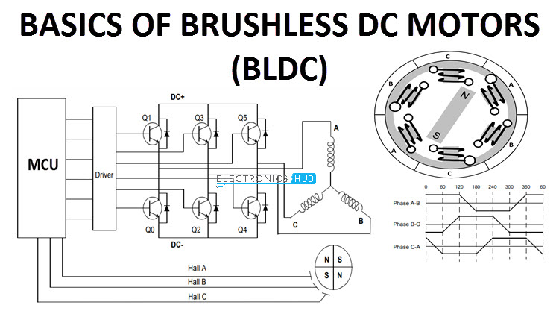The brushless DC Motor looks almost the same as a brushed DC Motor from a modelling perspective, also having a proportional relationship between the current and the torque produced & the voltage and the rpm (Rotations per minute). Unlike brushed DC motors in which the commutation occurs in a mechanical manner, the brushed DC Motors are electronically commuted.

The brushed DC motors make use of brushes to prevent the problem of having the wires supply current directly to the moving armature, where the armature is an electromagnet (due to the flow of current) and the stator is a permanent magnet. Now, one would wonder that how are the Brushless DC Motors able to transfer current to a moving armature without the use of brushes. This is taken care by a simple interchange as compared to the brushed DC Motors. In brushless DC Motors, the electromagnets are not rotated and instead the permanent magnets are rotated to provide the torque, hence, the stator is an electromagnet and the armature is a permanent magnet.

To carry out this process, the brush system of arrangement is replaced by a smart electronic controller, which provides with the similar amount of power as in brushed DC Motors.  BLDC motors have many advantages over brushed DC motors and induction motors, such as a better speed *versus* torque characteristics, high dynamic response, high efficiency and reliability, long operating life (no brush erosion), noiseless operation, higher speed ranges, and reduction of electromagnetic interference (EMI).

The mechanism of the Brushless DC Motor works in the principle: - the stator is divided into 6 coil arrangements and the armature (permanent magnet) is placed either in the core or outside depending upon its construction. To make the motor work, DC power is supplied to the stator and with that, it becomes an electromagnet. With the armature having its magnetic properties due to the permanent magnet, different coils of the stator are applied with DC power to generate a magnetic polarity such as the coil nearer to one pole of the armature has an opposite polarity so that the armature repels and starts rotating. When the rotor completes one half rotation (180 degrees), the initial coil is energized with an opposite polarity (which can be achieved by changing the direction of current flow).

The process can be better understood by the GIF below:



The only issue with this is that how do we know which coil to energize and with what polarity at what instant? That is when the smart electronically controlled tool takes up. To tackle this issue, this motor uses a sensor called Hall-Effect sensors. These sensors detect the position of the armature and then determine which coils to energize with specific polarities.

ADVANTAGES OF BRUSHLESS DC MOTOR

* Less overall maintenance due to lack of brushes
* Operates effectively at all speeds with rated load
* High efficiency and high output power to size ratio
* Reduced size with far superior thermal characteristics
* Higher speed range and lower electric noise generation